Health and Safety Handbook

CONTENTS

INTRODUCTION

HEALTH AND SAFETY POLICY STATEMENT

RESPONSIBILITIES AND RULES
Employees
Pupils

HEALTH AND SAFETY RULES
General
Working Practices
Hazard / Warning Signs and Notices
Working Conditions / Environment
Protective Clothing and Equipment
Fire Precautions
Accidents
Health
Rules Covering Gross Misconduct

ARRANGEMENTS FOR HEALTH AND SAFETY
Accident, Incident and Ill-Health Recording, Reporting and Investigation
Asbestos
Communication and Consultation
Disabled Persons including pupils with Special Educational Needs (SEN) Fire
Fire and Emergency Evacuation
Ladders and Stepladders
Lone Workers
Manual Handling
Personal Protective Equipment
Safeguarding
Smoking
Stress
Supporting Pupils with Medical Needs
Training
Violence to Staff
Visitors
Window Restrictors
Work At Height
HEALTH AND SAFETY HANDBOOK ACKNOWLEDGEMENT FORM

INTRODUCTION

This handbook contains the health and safety information you require to comply with our Health and Safety Policy. After reading it you will be required to sign to confirm that it has been brought to your attention. If you have any queries regarding the contents please do not hesitate to ask.

Glendower Prep School takes its responsibility for health and safety very seriously and is committed to a programme of progressive improvement that requires input from all its employees. If you see anything during your work that gives rise to a concern you are positively encouraged to report it to your manager.

Safety is everyone’s responsibility and that includes you.

HEALTH AND SAFETY POLICY STATEMENT

As governors of Glendower Preparatory School (‘Glendower’) we fully recognise our collective responsibility for providing, so far as is reasonably practicable, a safe and healthy school for all of our employees, pupils, contractors, visitors (including parents) and others who could be affected by our activities. In our role as employer we attach high priority to ensuring that all the operations within the school environment, both educational and support, are delivered in an appropriate manner. The governors are committed to promoting the welfare of all in our community so that effective learning can take place.
We fulfil our responsibility as governors of Glendower by appointing, the Chair of the Health and Safety Committee a governor with responsibility for overseeing health and safety.
Day-to-day responsibility for the operation of health and safety at the school is vested with the Headmistress who delegates responsibility to the Bursar and Site Manager. However, as governors, we have specified that that the school should adopt the following framework for managing health and safety:
The governor overseeing health and safety attends the meetings of the school's health and safety committee termly and receives copies of all relevant paperwork.
A report on health and safety covering: statistics on accidents to pupils, staff and visitors, staff training, fire drills, and all new or revised policies and procedures is tabled at each term's meeting of the Health and Safety Committee.
The minutes of the Committee's discussion on health and safety are tabled at each meeting of the full Governing Board together with any other issues on health and safety that the committee chairman wishes to bring to the Board's attention.
The external fabric of the school, its plant, equipment and systems of work are surveyed and inspected regularly by competent professionals.
These reports (as per point above) are considered by the Bursar and Site Manager (together with other defects) form the basis of the school's routine maintenance programmes.
The school's adherence to health and safety in catering and cleaning of the food preparation and eating areas is subject to external inspection by the Environmental Health Officer (EHO). In addition the Catering Contractors (Brookwood) arrange for an independent hygiene and safety audit of food storage, meal preparation and food serving areas up to three times a year, together with regular external deep cleaning and pest control services, and that the Site Manager reports on all these aspects to the Health and Safety Committee.
The school has fire risk assessments, carried out by Ellis Whittam which are reviewed every year for progress on completion of items in the action plan, and updated every two years, more frequently if significant changes are made to the interior of buildings or new buildings are bought or added. The Health and Safety Committee reviews this risk assessment every time it is amended.
An external health and safety consultant (Ellis Whittam’) reviews the overall arrangements for health and safety, including fire safety, the general state of the school, and reports on actions required with recommended timescales. The progress of implementation is monitored by the Health and Safety Committee.
The school has a competent person undertake a risk assessment for legionella, every two years and a quarterly water sampling and testing regime in place.
The school has a comprehensive policy in place for the training and induction of new staff in health and safety related issues which includes basic 'manual handling' and 'working at height training'. First aid training is provided to all members of staff.
All members of staff are responsible for taking reasonable care of their own safety, that of pupils, visitors, temporary staff, volunteers and contractors. They are responsible for co-operating with the head, the bursar and other members of the Senior Leadership Team ("SLT") in order to enable the governors to comply with health and safety duties. Finally, all members of staff are responsible for reporting any significant risks or issues to the bursar.
All employees are sent copies of this statement as well as the Health and Safety Handbook.

Signed (…………………....) Chair of Health & safety Committee, for and on behalf of the Board

Signed (……………………) Headmistress

Date (………….…)

HEALTH AND SAFETY RESPONSIBILITIES

RESPONSIBILITIES AND RULES

The Governors, Head Teacher, senior staff and designated health and safety staff will take all reasonable steps to identify and reduce hazards to a minimum. To assist in this all staff and pupils must be aware of their own and others personal safety, and in any of the schools activities, both on and off site.

Employees

All employees must:

- take reasonable care of their own safety

- take reasonable care of the safety of others affected by their actions

- observe the safety rules

- comply with the Health and Safety Policy

- conform to all written or verbal instructions given to them to ensure their personal safety and the safety of others

- dress sensibly and safely for their particular working environment or occupation

- conduct themselves in an orderly manner in the work place and refrain from any antics or pranks

- use all safety equipment and/or protective clothing as directed

- avoid any improvisations of any form which could create an unnecessary risk to their personal safety and the safety of others

- maintain all equipment in good condition and report defects to their supervisor

- report any safety hazard or malfunction of any item of plant or equipment to their supervisor

- report all accidents to their supervisor whether an injury is sustained or not

- attend as requested any health and safety training course

- observe all laid down procedures for processes, materials and substances used

- observe the fire evacuation procedure and the position of all fire equipment and fire exit routes.

Pupils

All pupils must:

- co-operate with Teachers and school staff on health and safety matters;
- not interfere with anything provided to safeguard their own health and safety; • take reasonable care of their own health and safety; and
- report all health and safety concerns to a Teacher.

HEALTH AND SAFETY RULES

General

- It is the duty of all employees to co-operate with the Board of Governors in fulfilling our legal obligations in relation to health and safety.

- Employees must not intentionally or recklessly interfere with anything provided in the interests of health, safety or welfare.

- Employees are required to notify to management of any unsafe activity, item or situation.

Working Practices

- Employees must not operate any item of plant or equipment unless they have been trained and authorised.

- Employees must make full and proper use of all equipment guarding.

- Employees must not clean any moving item of plant or equipment.

- Employees must not make any repairs or carry out maintenance work of any description unless authorised to do so.

- Employees must use all substances, chemicals, liquids etc, in accordance with all written instructions.

- Employees must not smoke except in prescribed areas.

Hazard / Warning Signs and Notices

- Employees must comply with all hazard/warning signs and notices displayed on the premises.

Working Conditions / Environment

- Employees must make proper use of all equipment and facilities provided to control working conditions/ environment.

- Employees must keep stairways, corridors, classrooms and work areas clear and in a clean and tidy condition.

- Employees must dispose of all rubbish, scrap and waste materials using the facilities provided.

- Employees must clear up any spillage or liquids in the prescribed manner.

- Employees must deposit all waste materials and substances at the correct disposal points and in the prescribed manner.

Protective Clothing and Equipment

- Employees must use all items of protective clothing/equipment provided as instructed.

- Employees must store and maintain protective clothing/equipment in the approved manner.

- Employees must report any damage, loss, fault or unsuitability of protective clothing/equipment to their supervisor.

Fire Precautions

- Employees must comply with all laid down emergency procedures.

- Employees must not obstruct any fire escape route, fire equipment or fire doors.

- Employees must not misuse any fire fighting equipment provided.

- Employees must report any use of fire fighting equipment to their supervisor.

Accidents

- Employees must seek medical treatment for work related injuries they receive by contacting a designated first aider. Upon returning from treatment they must report the incident to their supervisor.

- Employees must ensure that any accident or injury treatment is properly recorded in the Accident Book.

- Employees must notify management of any incident in which damage is caused to property.

Health

- Employees must report to management any medical condition or medication which could affect the safety of themselves or others.

- Employees must co-operate with the management on the implementation of the medical and occupational health provisions.

Rules Covering Gross Misconduct

An employee will be liable to summary dismissal if they are found to have acted in any of the following ways:

- A serious or wilful breach of Safety Rules.

- Unauthorised removal or interference with any guard or protective device.

- Unauthorised operation of any item of plant or equipment.

- Unauthorised removal of any item of first aid equipment.

- Wilful damage to, misuse of or interference with any item provided in the interests of Health and Safety or welfare at work.

- Unauthorised removal or defacing or any label, sign or warning device.

- Horseplay or practical jokes which could cause accidents.

- Making false statements or in any way deliberately interfering with evidence following an accident or dangerous occurrence.

- Misuse of any item of equipment, utensil, fitting/ fixture, vehicle or electrical equipment.

- Deliberately disobeying an authorised instruction.

ARRANGEMENTS FOR HEALTH AND SAFETY

Accident, Incident and Ill-Health Recording, Reporting and Investigation

If you have an accident whilst in the course of carrying out your work, you must report the accident, however small, to a First Aider. The First Aiders are:

As per the list in the Office

First aid boxes are sited in the following locations:

Sick Room

You must ensure details of the accident are recorded in the Accident Book, which is kept:

In the Office

All staff must make themselves familiar with the location of the first aid point, the names of the first aid personnel and the location of the Accident Book.

All near misses must also be reported to the Head Teacher as soon as possible so that action can be taken to investigate the causes and to prevent recurrence.

Definitions

An accident is an unplanned event that causes injury to persons, damage to property or a combination of both.

A near miss/incident is an unplanned event that does not cause injury or damage but could do so.

A work-related illness is a prescribed illness that is obtained by an employee through the course of work or from a non-employee as a result of activities carried out by the school.

Asbestos

The school will protect employees, pupils and other persons potentially exposed to asbestos as far as is reasonably practicable. Everyone who needs to know about the presence of asbestos will be alerted. No one will be allowed to start any work that could disturb asbestos unless the correct procedures are to be employed.

Where a problem arises relating to the condition of asbestos-containing material, the employee must inform the Bursar.

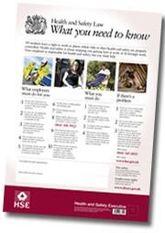
Communication and Consultation

The school has established effective lines of communication so as to involve and consult our employees.

These include:

- individual conversations
- notice boards
- internal publications
- staff meetings
- Health and Safety meetings.

In addition the school displays the ‘Health and Safety Law – What You Need To Know’ poster on the Notice Board.

Disabled Persons including pupils with Special Educational Needs (SEN)

The school will give full and proper consideration to the needs of disabled employees, pupils and visitors.

To achieve this, the school will:

- treat all disabled employees, pupils and visitors with respect and dignity, both in the provision of a safe working environment and in equal access to the school’s facilities

- ensure that risk assessments are undertaken of the special needs of the disabled and carry out reasonable adjustments to the premises and/or employment arrangements

- encourage employees with special needs to suggest any premises or task improvements to their line managers

- discipline any employees found treating their disabled colleagues with less than the expected standards of respect and dignity

- in an emergency evacuation, ensure suitable plans are in place which will assist disabled people to leave the premises swiftly.

Fire and Emergency Evacuation

All reasonable steps will be taken to prevent a fire occurring. In the event of fire, the safety of life will override all other considerations, such as saving property and extinguishing the fire.

The school does not require persons to attempt to extinguish a fire but extinguishing action may be taken if it is safe to do so. Immediate evacuation of the building must take place as soon as the evacuate signal is given. All occupants, on evacuation, should report to the pre-determined assembly points.

Re-entry of the building is strictly prohibited until the fire brigade officer or a senior person present declares it is safe to do so.

Employees are encouraged to report any concerns regarding fire procedures so the organisation can investigate and take remedial action if necessary.

You should familiarise yourself with the location of the fire alarms, fire appliances, fire exits and assembly points.

 |  |  | Fire Extinguisher Chart
Extinguisher |  |  | Class of Fire
Colour | Type | Solids | Flammable Liquids | Flammable Gases | Flammable Metals | Electrical Contact | Cooking  Oils & Fats | Special Notes
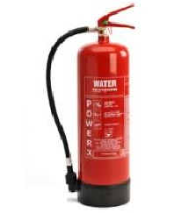Red | Water | Yes | No | No | No | No | No | Dangerous if used on 'liquid fires' or live electricity.
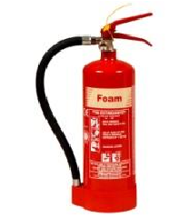  Cream | Foam | Yes | Yes | No | No | No | No | Not practical for home use.
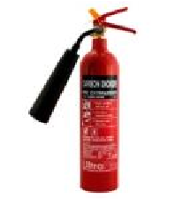  Black | Carbon  Dioxide  (CO2) | No | Yes | No | No | Yes | No | Safe on high and low voltages.

Fire and Emergency Evacuation

See also the Fire Safety Policy.

IF YOU DISCOVER A FIRE:
Operate the nearest fire alarm call point.

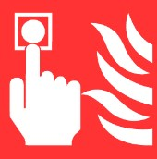
IF IT IS SAFE TO DO SO AND IF YOU HAVE AUTHORISATION AND
APPROPRIATE TRAINING, attack the fire with the fire fighting equipment provided

Always ensure there is a safe exit route before attempting to extinguish any fire.

Leave the building immediately if you cannot control the fire or your escape route is threatened.

ON HEARING THE ALARM:

The fire alarm sound is a Bell/Siren

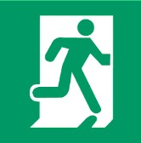
Immediately vacate the premises by the nearest available exit

Close all windows and doors behind you

Go to assembly point
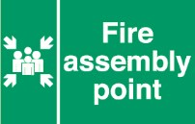
Report to the person in charge of your assembly point

The assembly point is located:

Queens Gate Road

DO NOT RE-ENTER THE BUILDING TO COLLECT PERSONAL BELONGINGS.

DO NOT RE-ENTER THE BUILDING UNTIL TOLD TO DO SO BY THE SENIOR PERSON PRESENT

VISITORS

All visitors should be escorted to the assembly point by their host.

It is important that they do not leave the area before notifying the senior person present.

LIAISING WITH EMERGENCY SERVICES

The senior person present will meet and liaise with the emergency services and any other interested parties, giving them pertinent information related to the emergency situation, such as location and details of emergency, location and presence of hazardous and flammable materials, head count statistics, etc.

Ladders and Stepladders

Staff are discouraged from using ladders and stepladders. However, if you have used such equipment before and there is no alternative, and you consider it safe to do so this guidance is to help you:

- know when to use a ladder
- decide how to go about selecting the right sort of ladder for the particular job
- understand how to use it
- know how to look after it
- take sensible safety precautions.

When is a ladder the most suitable access equipment?

As a guide, only use a ladder or stepladder:

- in one position for a maximum of 30 minutes

- for ‘light work’ - they are not suitable for strenuous or heavy work. If a task involves you carrying more than 10 kg (a bucket of something) up the ladder or steps it will need to be justified by a detailed manual handling assessment

- where a handhold is available on the ladder or stepladder

- where you can maintain three points of contact (hands and feet) at the working position.

On a ladder where you cannot maintain a handhold, other than for a brief period of time, other measures will be needed to prevent a fall or reduce the consequences of one. On stepladders where a handhold is not practicable you will need to consider whether it is safe to work or not.

Is it a safe place to use a ladder or stepladder?

As a guide, only use a ladder or stepladder:

- on firm ground or spread the load (e.g. use a board)

- on level ground - for stepladders refer to the manufacturer’s instructions, for ladders the maximum safe ground slopes on a suitable surface (unless the manufacturer states otherwise) are as follows:

o side slope 16° – but the rungs still need to be levelled o back slope 6°.

- on clean, solid surfaces (paving slabs, floors etc). These need to be clean (no oil, moss or leaf litter) and free of loose material (sand, packaging materials etc) so the feet can grip. Shiny floor surfaces can be slippery even without contamination.

Never stand ladders or stepladders on moveable objects, such as pallets, bricks, lift trucks, tower scaffolds, vans, stacks of paper or boxes etc. If the ladder or stepladder won’t reach, you need to use a more suitable type of access equipment.

You should only use ladders or stepladders:

- where they will not be struck by vehicles, by protecting them with suitable barriers or cones

- where they will not be pushed over by other hazards such as doors or windows, by securing doors (not fire exits) and windows where possible. If this is impractical, have a person standing guard at a doorway, or inform building occupants not to open windows until they are told it is safe to do so
- where pedestrians are prevented from walking under them or near them, by using barriers, cones or, as a last resort, a person standing guard at the base.

Safety in use – ladders

On a ladder do not:

- overload it – you and anything you are carrying should not exceed the highest load stated on the ladder

- overreach - keep your navel inside the stiles and both feet on the same rung throughout the task

- rest ladders against weak upper surfaces e.g. glazing or plastic gutters. Use effective spreader bars instead

- use the top three rungs

- move the ladder while someone is using it

- extend a ladder while standing on the rungs

- slide down the stiles.

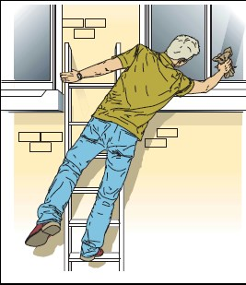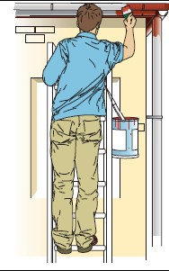

Overreaching – not maintaining Maintaining 3 points of contact
3 points of contact Do:

- make sure the ladder rungs are level. This can be judged by the naked eye. Ladders can be levelled using specially designed devices but not by using bits of brick or whatever else is at hand

- check that the weather is suitable - do not use ladders in strong or gusting winds

- wear sensible footwear. Shoes should not have the soles hanging off, have long or dangling laces, or be thick with mud or other slippery contaminants. High heels are also unsuitable!

- check that you are fit. Certain medical conditions or medication, or a fear of heights, could
mean that you shouldn’t be working at height

- know how to tie a ladder properly.

You should also avoid holding items when climbing (for example by using tool belts). If you must carry something you must still have one free hand to grip the ladder. Remember the THREE POINTS OF CONTACT RULE – 2 hands and 1 foot or 2 feet and 1 hand MUST BE on the ladder at all times when climbing and descending.

Ladders must be erected at an angle of 75°. To judge the angle use the angle indicator marked on the stiles of some ladders or the 1 in 4 rule (1 unit out for every 4 units up).

Ladders used for access to another level must be tied and should extend at least 1 metre above the landing point to provide a secure handhold.

Correct 1 in 4 angle:

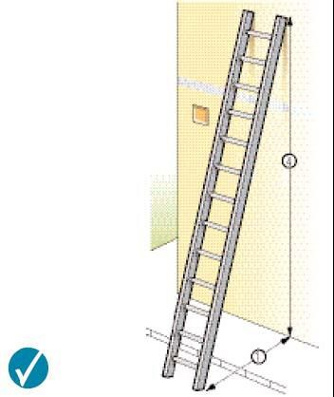

Securing a ladder

To prevent the ladder slipping away from the wall, or slipping sideways, you must secure it. The options for securing a ladder are:

- tie the ladder to a suitable point, making sure both stiles are tied

- where this is not practical, use a safe, unsecured ladder or a ladder supplemented with an effective ladder stability device

- if this is not possible, then securely wedge the ladder e.g. against a wall

- if none of the above can be achieved, foot the ladder. Footing is the last resort and other methods of securing the ladder should be used in preference.

If you do have to foot a ladder, be aware that this will not stop a ladder slipping sideways at the top. Individuals footing ladders should apply weight downwards on the ladder by standing on a rung, or by pushing against the ladder stiles (although this is less effective).

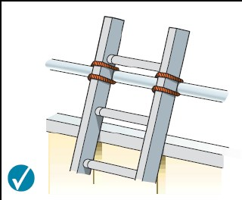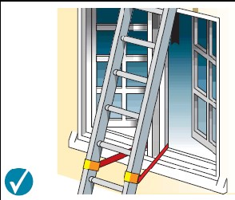

Ladder tied at the top stiles (correct for Tying part way down working on, but not for access)

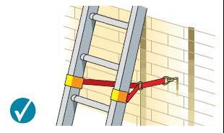 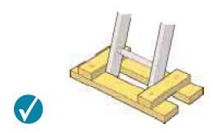 Tying near the base Securing at the base

Safety in use – stepladders

On a stepladder do not:

- overload it – you and anything you are carrying should not exceed the highest load stated on the stepladder

- use it in locations where the restraint devices cannot be fully opened. Any locking devices must also be engaged

- use the top two steps of a stepladder, unless a suitable handrail is available on the stepladder

- use the top three steps of swing-back or double-sided stepladders, where a step forms the very top of the stepladder.

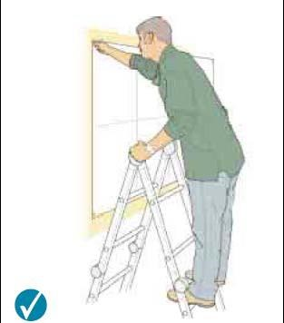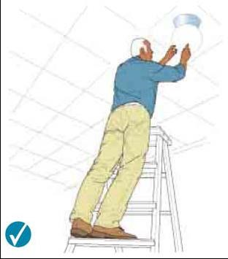

Correct – two clear rungs. Don’t Correct – 3 clear rungs, do not work any higher up this type of work any higher on this type of
stepladder. stepladder

When using stepladders, avoid work that imposes a side loading, such as side-on drilling through solid materials (e.g. bricks or concrete), by having the steps facing the work activity. Where side-on loadings cannot be avoided you should prevent the steps from tipping over, for example by tying the steps to a suitable point, or you should use a more suitable type of access equipment.

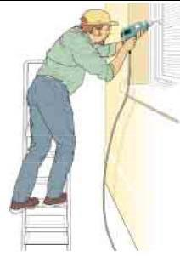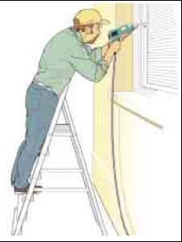

Incorrect – steps side on to work activity Correct – steps facing work activity

Where you cannot maintain a handhold (e.g. putting a box on a shelf), the use of a stepladder will have to be justified by taking into account:

- the height of the task
- a safe handhold still being available on the stepladder
- whether it is light work
- whether it avoids side loading
- whether it avoids overreaching • whether your feet are fully supported
- whether you can tie the stepladder.

Consider tying a stepladder where possible and helpful to the task (e.g. side-on working or where two free hands are needed). Stepladders should not be used for access to another level unless they have been designed for this.
Is the ladder or stepladder safe to be used?

You must check that the ladder or stepladder is in a safe condition before using it (a daily pre-use check). As a guide, only use ladders or stepladders that:

- have no visible defects

- have a current detailed visual inspection (look for an inspection label)

- are suitable for work use. Use Class 1 or EN 131 ladders or stepladders at work because domestic (Class 3) ones are not normally suitable for use at work

- have been maintained and stored in accordance with the manufacturer’s instructions.

Also, you must always use a non-conductive ladder or steps for any necessary live electrical work.

Pre-use checks

Look for obvious visual defects before using a ladder or stepladder. Check that:

- all the ladder feet are fitted

- the feet are in good repair (not loose, missing, splitting, excessively worn, secure etc)

- the feet are clean - the feet should be in contact with the ground. Ladder feet should also be checked when moving from soft/dirty ground (e.g. dug soil, loose sand/stone, a dirty workshop) to a smooth, solid surface (e.g. paving slabs), to ensure the foot material and not the dirt (e.g. soil, embedded stones or swarf) is making contact with the ground

- all the screws, bolts and hinges are secure

- on a stepladder, that the “spreaders” on the ladder can be locked into place

- There are no other obvious signs of damage such as cracks.

If you find a problem, DO NOT USE the ladder. It should be repaired (if practicable) or destroyed

Storage

When storing ladders and stepladders, store them in a well ventilated area to prevent sagging and warping. Store straight ladders in flat racks or on wall brackets, don’t hand them from the rungs. Store step ladders in the closed, vertical position.

The information in this Guidance is based on the HSE leaflet ‘Safe use of ladders and step ladders’.

Lone Workers

Rules for lone workers : staff should not usually remain in school after 7pm during school term time. Outside these times and in the holidays and weekends staff should only attend if agreed in advance with the site manager and/ bursar. Lone workers should sign in on arrival and out on departure.

- Anyone working alone must have access to a telephone and ensure that a relative or colleague is aware;
- The Site Manager (or other named person) must be informed of anyone intending to work late and a satisfactory arrangement made for locking up the building;
- When the Site Manager (or other named person) is not present all lone workers, for reasons of security, health and safety, should lock themselves in the building.
- Staff must not place themselves in danger by challenging intruders or vandals but should call the police for assistance.
- Staff working alone have a responsibility for making themselves familiar with and following the school’s safety procedures and location of safety equipment.
- If staff rely on mobile phones they must ensure that their network has good reception within school. Although phones can give extra reassurance, they do not provide complete protection and staff should still be alert for their own personal safety at all times.
- In the situation where two or more people are working in isolated areas of an otherwise unoccupied building, personnel should keep each other informed about their movements.

Opening/Closing School

- When the last person has left the building and notified the Site Manager (or other named person), he should then secure the building. This includes the closing of all fire doors, activating the intruder alarm and leaving on any emergency and exterior lights.
- When the Site Manager (or other named person) arrives in the morning he must make a quick examination of the exterior of the building to make sure that there are no signs of a break-in or of anyone having been in the building. If the caretaker is in any doubt he should contact the Police/security firm and should never enter the building if he is unsure of his safety. • Key holders are also advised to inform someone when they are attending an alarm call out.

Emergency Considerations

Lone workers should be capable of responding correctly to emergencies. Risk assessment should identify foreseeable events. Emergency procedures should be established and the people concerned trained in using the procedures.

Emergency Procedures may need to cover:

- fires resulting from the activity or work being undertaken
- if a person has an accident what needs to be done to recover them, especially important in laboratories
- actions to be taken in case of a chemical spill
- actions to be taken in the event of power failure (for example where the person is
- reliant on power for their safety systems or for egress from a building e.g. power operated doors).

Manual Handling

Staff are strongly discouraged from lifting any heavy items. If in doubt always discuss in advance with the Site Manager. Unnecessary or incorrect handling can cause injury, in particular to the back.

Do not try to lift anything beyond your individual capability and before ascertaining weight, stability and centre of gravity.

The correct handling technique required to lift items safely is demonstrated below:

1 Planning

Plan the lift, consider where the load is to be placed, the distances involved; are there any obstructions such as closed doors, is assistance required and can handling aids or equipment be used?

2 Feet

The feet should be positioned apart (shoulder width), one foot ahead of the other in the direction of the intended movement

3 Knees

Adopt a good posture for handling with the knees bent (not squat – don’t kneel), in order to gain the most effective power from the thigh muscles

4 Back

The back should be straight - not necessarily vertical (15° - 20° from vertical is alright) keeping the natural curve of the spine. It may help to tuck in the chin. If necessary, lean forward a little over the load to get a good grip and to keep the centre of gravity over the load.

5 Arms

The arms should be close to the body (nearer the centre of gravity) with the shoulders level and facing the same direction as the hips.

6 Hands

Ensure a firm grip on the load. Holding the load this way is also less tiring than keeping the fingers straight.

7 Head

Raise the chin out and up as the lift begins, otherwise this results in round shoulders and a curved spine.

8 Moving the load

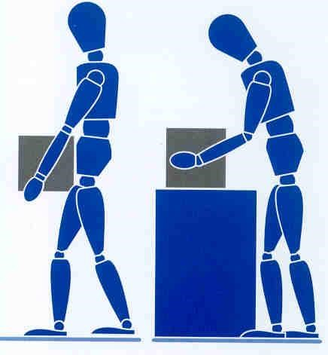

- Keep the load as close to the trunk for as long as possible, and where relevant, keep the heaviest side of the load close to the body. Slide the load towards you if required.

- Lift smoothly

- Move the feet not the trunk when turning to the side, i.e., don’t twist.

- Put the load down and then slide the load into the required position if necessary.

9 Team Handling

Handling by two or more people may make possible an operation that is beyond the capability of one person, or reduce the risk of injury to a solo handler.
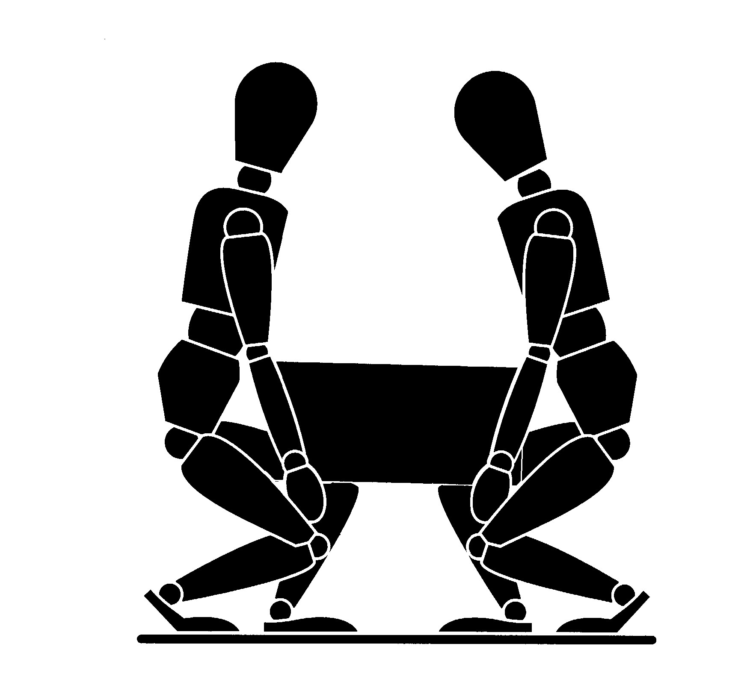

Additional difficulties may arise if team members impede each other’s vision or movement, or if the load offers insufficient good handholds. This can occur particularly with compact loads which force the handlers to work close together or where the space available for movement is limited.

When lifting loads at or near floor level is unavoidable, handling techniques which allow the use of relatively strong leg muscles rather than those of the back are preferable, provided the load is small enough to be held close to the trunk. In addition, if the task includes lifting to shoulder height, allow the handlers to change hand grip. Bear in mind, however, that such techniques impose heavy forces on the knees and hip joints which must carry both the weight of the load and the weight of the rest of the body.

The closeness of the load to the body can also be influenced by foot placement. The elimination of obstacles which need to be reached over or into will permit the handler’s feet to be placed beneath or adjacent to the load before beginning the manual handling operation.

Personal Protective Equipment

The school provides personal protective equipment (PPE) when the risk presented by a work activity cannot be eliminated or adequately controlled by other means. When it is provided, it is because health and safety hazards have been identified that require the use of PPE and it is therefore necessary to use it in order to reduce risks to a minimum.

Employees and volunteers provided with PPE must:

- wear the PPE as instructed or where indicated by signage
- maintain it in good condition
- report any defects to your manager
- ensure the PPE fits correctly, is comfortable and fully adjusted.

Safeguarding

All education professionals, including administrative and facilities staff as well as teaching staff, have a statutory duty of care to all pupils. This duty extends to promoting the welfare of pupils who require additional support but are not suffering harm or at immediate risk of harm.

The school will promote awareness and best practice to deal with situations of suspected abuse or neglect and situations in which staff are best placed to observe such signs. The school has appointed the Deputy Head as the designated safeguarding lead, who is responsible for providing support to staff members in their safeguarding duties and for liaising closely with the relevant social services such as children’s social care.

Staff Responsibilities

The school requires all staff to:

- assist in providing a safe environment in which children can learn
- raise all concerns with the designated safeguarding lead, including concerns about other staff members
- always err on the side of caution and report suspected cases of abuse or neglect
- report concerns directly to children’s social care if it is not possible to raise them with the designated safeguarding lead
- always act in the best interests of the child.

If at any point there is a risk of immediate serious harm to a child, staff members should make an immediate referral to children’s social care. If the child’s situation does not improve, staff members with concerns should press for re-consideration.

Record Keeping

We will ensure that appropriate, accurate, legible and contemporaneous records of safeguarding concerns are made and stored securely in accordance with the Data Protection Act 1998.

Further Information

All staff should refer to the School Safeguarding Policy, kept in the Office, for full details of the school’s policy and arrangements for safeguarding.

Smoking

It is the policy of the school that all of its premises are smoke-free and that all staff and pupils have a right to work in a smoke-free environment.
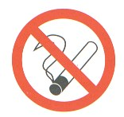
Smoking is prohibited throughout the entire school, including the use of all artificial smoking aids (electronic or otherwise) with no exceptions. This policy applies to all employees, pupils and visitors in all areas of the school, including school vehicles.

Implementation

All staff are obliged to adhere to and facilitate the implementation of the policy.

The school will ensure that all staff and contractors are aware of the policy on smoking. They will also ensure that all new personnel are given a copy of the policy on recruitment or induction.

Appropriate 'no smoking' signs will be clearly displayed at or near the entrances to the premises. Signs will also be displayed in school vehicles that are covered by the law.

Stress

The Health and Safety Executive define stress as “the adverse reaction people have to excessive pressure or other types of demand placed on them”. This makes an important distinction between pressure, which can be a positive state if managed correctly, and stress which can be detrimental to health.

Stress at work can come about for a variety of reasons. It may be excessive workload, unreasonable expectations, or overly-demanding work colleagues. As a reasonable school, we try to ensure that you are in a pleasant working environment and that you are as free from stress as possible.

Employees who experience unreasonable stress which they think may be caused by work should raise their concerns with their manager or through the school’s grievance procedure. If deemed appropriate, the school will provide access to confidential counselling for staff affected by stress caused either by work or external factors

Following action to reduce the risks, they shall be reassessed. If the risks remain unsustainable by the member of staff concerned, efforts shall be made to reassign that person to other work for which the risks are assessed as tolerable.

Supporting Pupils with Medical Needs

The school’s policy is to support pupils to attend school who have a medical condition. The school will therefore support the administration of short and long term medication and medical techniques where this is necessary for the pupil to continue to be educated at school. The school will also put in place procedures to deal with emergency medical needs.

The school will establish procedures to ensure that all concerned, staff, parents, pupils and, where relevant, health professionals are aware of the student’s condition and what steps have been agreed either to manage the condition on a daily basis or to be implemented in case of an emergency.

Individual health care plans are in place for those pupils with significant medical needs e.g. chronic or ongoing medical conditions such as diabetes, epilepsy, anaphylaxis etc. These plans will be completed at the beginning of the school year / when child enrols / on diagnosis being communicated to the school and will be reviewed/updated annually.

Administering Medicines

No child under 16 should be given medicines without their parent’s written consent. Any member of staff giving medicines to a child should check: the child’s name; prescribed dose; expiry date; written instructions provided by the prescriber on the label or container.

If in doubt about any procedure staff should not administer the medicines but check with the parents or a health professional before taking further action. If staff have any other concerns related to administering medicine to a particular child, the issue should be discussed with the parent, if appropriate, or with a relevant health professional.

Self-Management

It is good practice to support and encourage children, who are able, to take responsibility to manage their own medicines from a relatively early age. As children grow and develop they should be encouraged to participate in decisions about their medicines and to take responsibility.

Where children have been prescribed controlled drugs, staff need to be aware that these should be kept safely. However children could access them for self-medication if it is agreed that it is appropriate.

Refusing Medicines

If a child refuses to take medicine, staff should not force them to do so, but should note this in the child’s record and follow the agreed procedures. Parents should be informed of the refusal on the same day.

Educational Visits

The school will consider what reasonable adjustments they might need to make to enable children with medical needs to participate fully and safely on visits. This might include reviewing and revising the visits policy and procedures so that planning arrangements will include the necessary steps to include children with medical needs. It might also include risk assessments for such children.

Sometimes additional safety measures may need to be taken for outside visits. It may be that an additional supervisor, a parent or another volunteer might be needed to accompany a particular child. Arrangements for taking any necessary medicines will also need to be taken into consideration. Staff supervising visits should always be aware of any medical needs and relevant emergency procedures. Copies of health care plans should be taken on visits in the event of the information being needed in an emergency.

Sporting Activities

Any restrictions on a child’s ability to participate in PE should be recorded in their individual health care plan. All adults should be aware of issues of privacy and dignity for children with particular needs.

Some children may need to take precautionary measures before or during exercise and may also need to be allowed immediate access to their medicines such as asthma inhalers. Staff supervising sporting activities should consider whether risk assessments are necessary for some children, be aware of relevant medical conditions and any preventative medicine that may need to be taken and emergency procedures.

School Transport

Where pupils have life threatening conditions, specific health care plans should be carried on vehicles. The care plans should specify the steps to be taken to support the normal care of the pupil as well as the appropriate responses to emergency situations.

All drivers and escorts should have basic first aid training. Additionally trained escorts may be required to support some pupils with complex medical needs. These can be healthcare professionals or escorts trained by them.

Some pupils are at risk of severe allergic reactions. Risks can be minimised by not allowing anyone to eat on vehicles. All escorts should also be trained in the use of an adrenaline pen for emergencies where appropriate.

Non Prescription Medication

Non prescription medication should not be administered by school. This includes paracetamol and homeopathic medicines.

Staff may not know whether the pupil has taken a previous dose, or whether the medication may react with other medication being taken. A child under 16 should never be given aspirin containing medicine, unless prescribed by a doctor.

Where it is necessary to administer non-prescription medicine to a child, specific written permission must be obtained from parents / carers and the administration documented.

If a pupil suffers regularly from acute pain, such as migraine, the parents should authorise and supply appropriate painkillers for their child’s use, with written instructions about when the child should take the medication. A member of staff should notify the parents that their child has requested medication and supervise the pupil taking the medication if the parents have agreed to it being taken.

Training

Training in health and safety is a legal requirement and also helps create competent employees at all levels within the school to enable them make a far more effective contribution to health and safety, whether as individuals, teams or groups.

All employees will receive induction training.

Such training will cover:

fire procedures, warning systems, actions to be taken on receiving warning, locations of exits/escape routes, evacuation and assembly procedures, first aid/injury reporting procedures, names of first aiders/appointed persons, instruction on any prohibition areas (i.e. no smoking), issue of protective clothing/equipment and its use, instruction under COSHH, mandatory protection areas, thorough instruction applicable to their particular duties at work etc.

Training needs will be reviewed as a result of job changes, promotion, new activities or new technology, following an accident/incident and performance appraisal.

Records of training will be kept for all employees.

Employees must:

- participate in the induction training activities they have been required to attend or carry out

- work according to the contents of any training they receive

- ask for clarification of any points they do not fully understand

- not operate hazardous plant or equipment, use hazardous chemicals or carry out any hazardous activity unless they have been appropriately trained and instructed.

Violence to Staff

The school recognises that in certain situations violent behaviour towards staff may occur and therefore will take all reasonable measures to protect staff from violence and aggression.

We define violence and aggression as:

- actual or threatened physical assaults on staff
- psychological abuse of staff
- verbal abuse which includes shouting, swearing and gestures
- threats against employees.

If you are a witness or receive any violence or aggression towards you, then you should report this to a senior member of staff / your manager so that this can be recorded and investigated. The school will support the decision of any employee wishing to press charges against the individual(s) involved. Access to counselling can also be provided where required.

Visitors

In the interest of safety and security, the school will take the necessary measures to protect staff and visitors from any accidents or incidents that may occur during visiting.

Employees hosting visitors must ensure that:

- they are authorised to enter the premises or are accompanied

- they adhere to applicable health and safety instructions and rules during their visit

- adequate information is passed to ensure their safety including emergency information

- any protective clothing required is provided and worn

- any accidents / incidents involving visitors are reported through the accident reporting arrangements.

Employees aware of people on the premises who may be unauthorised should report these to their manager for action.

Emergency Action

In the event of the fire alarm sounding, all visitors should be escorted to the assembly point by their host. Visitors should not leave the area before notifying the senior person present.

Window Restrictors

The fitting and use of window restrictors within school premises is used to ensure the safety and security of members of staff, pupils and visitors. The school is particularly concerned with preventing persons from falling from height, and has fitted window restrictors to remove the possibility of persons opening a gap large enough for a person to fall through. It is therefore essential that all window restrictors are maintained in a good working order and that all staff report defects to their line manager as a matter of urgency.

If you discover a window restrictor that is damaged or broken you must report it to your line manager or the Facilities Manager. Any window restrictor that is found to be broken will be replaced or repaired as a matter of urgency, but you must ensure that you leave the window locked and do not open it until repairs are carried out. If the repair will not take place for more than a day, temporary signage should be put in place to indicate that the window should not be used.

HEALTH AND SAFETY HANDBOOK ACKNOWLEDGEMENT FORM

Please read the notes below and then sign this form.

Clearly, we will do all in our power to ensure the health and safety and welfare of all our staff and we look to our employees to abide by the Health and Safety standards laid down.

We have formulated our Health and Safety at Work Policy as legally required and this handbook informs you of those sections of the Policy which affect you.

You should read the information contained in this Handbook and adhere to the rules at all times.

Please discuss any queries you may have with your employer and sign this form.

I have read the Health and Safety Handbook and understand and accept its contents. I will keep myself informed of its contents.

Signature: Date:

Print Name:

